📘 HIRAGANA + MNEMONIC (FULL)

Vowel (Nguyên âm)
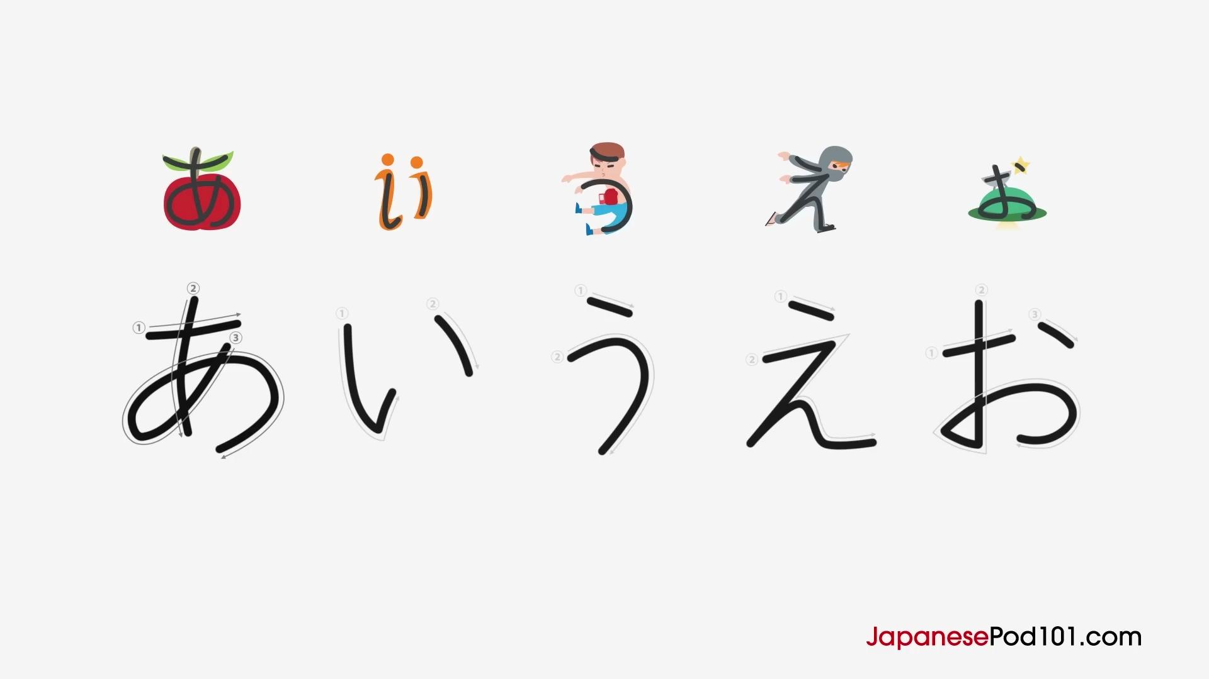
あ (a)
Mnemonic: Think of an Apple with a stem.
い (i)
Mnemonic: Imagine two "i"s side-by-side, like two eyes.
う (u)
Mnemonic: A boxer getting punched in the stomach, saying "Ugh!"
え (e)
Mnemonic: An Energetic ninja running.
お (o)
Mnemonic: A UFO in the sky. Note the extra stroke compared to "a".

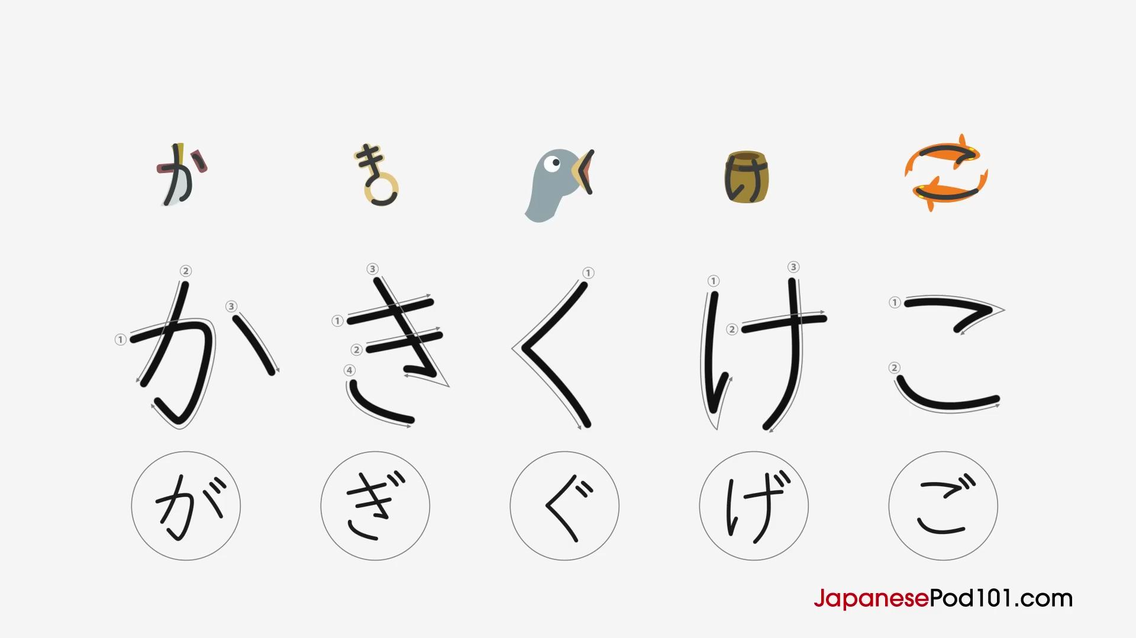

K Column
か (ka)
Mnemonic: A blade cutting a stick.
き (ki)
Mnemonic: It looks like a key.
く (ku)
Mnemonic: A cuckoo bird’s beak.
け (ke)
Mnemonic: A cake.
こ (ko)
Mnemonic: Two koi fish swimming around each other.

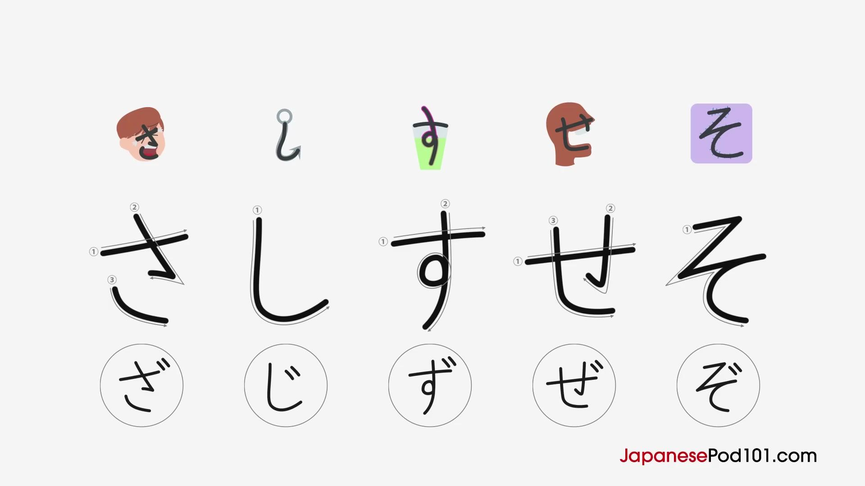

S Column
さ (sa)
Mnemonic: A sad face (missing one line).
し (shi)
Mnemonic: A fishing hook.
す (su)
Mnemonic: A sip of water (or straw in a glass).
せ (se)
Mnemonic: An "M" facing sideways.
そ (so)
Mnemonic: A zigzag sewing stitch.

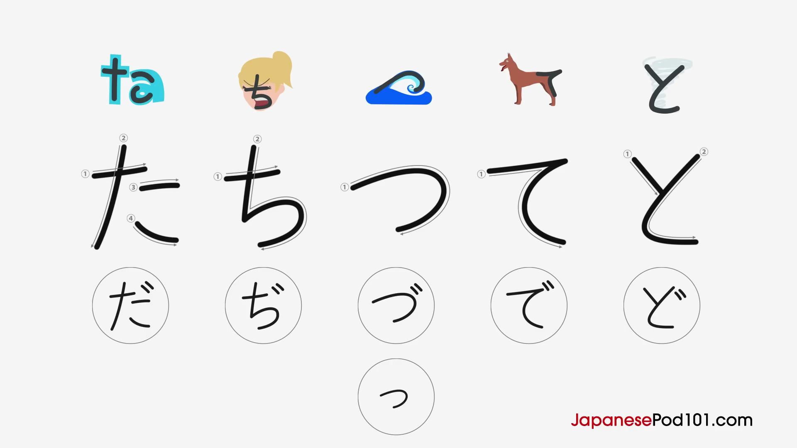

T Column
た (ta)
Mnemonic: Looks like a dog.
ち (chi)
Mnemonic: A cheerleader (mirror of さ).
つ (tsu)
Mnemonic: A tsunami wave.
て (te)
Mnemonic: Looks like a hand.
と (to)
Mnemonic: A tornado.

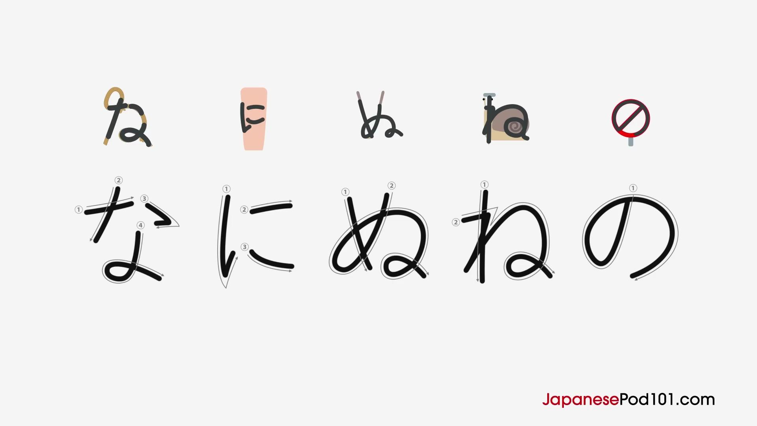

N Column
な (na)
Mnemonic: A complicated knot (or nut).
に (ni)
Mnemonic: A knee.
ぬ (nu)
Mnemonic: Chopsticks holding noodles.
ね (ne)
Mnemonic: A snail behind a nail.
の (no)
Mnemonic: A "no" sign (circle).

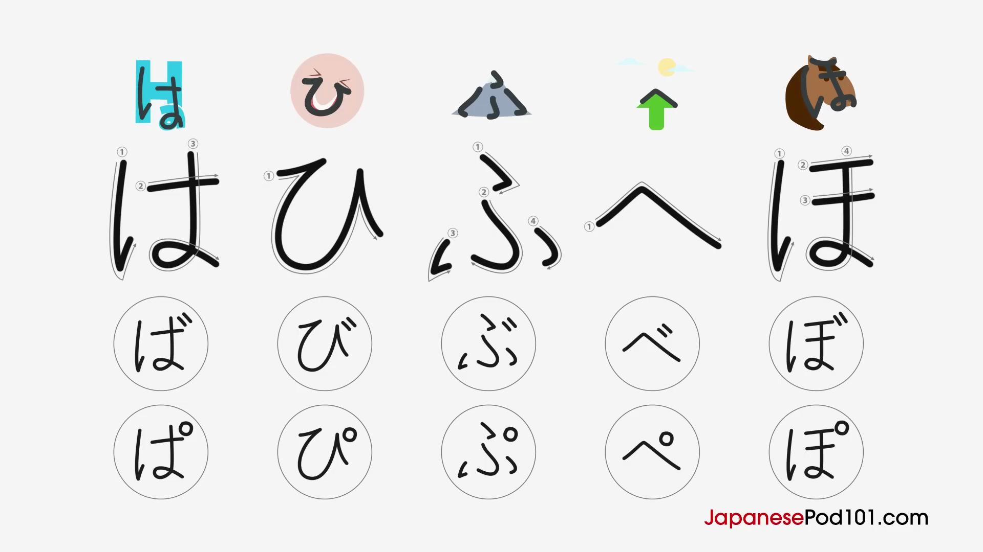

H Column
は (ha)
Mnemonic: Looks like an H with a loop.
ひ (hi)
Mnemonic: A smiling face saying "he he".
ふ (fu)
Mnemonic: Mount Fuji.
へ (he)
Mnemonic: An arrow pointing up to the sky.
ほ (ho)
Mnemonic: A horse’s face.

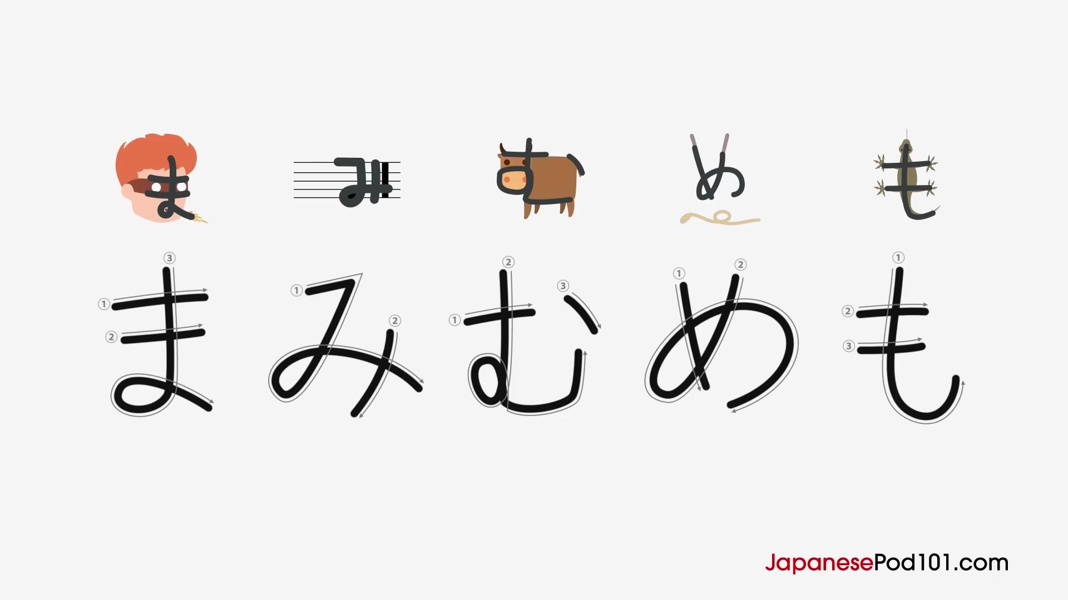

M Column
ま (ma)
Mnemonic: A man wearing a mask.
み (mi)
Mnemonic: A musical note.
む (mu)
Mnemonic: A cow saying "moo".
め (me)
Mnemonic: A messy face (dropped noodles).
も (mo)
Mnemonic: A monitor lizard with a long tail.

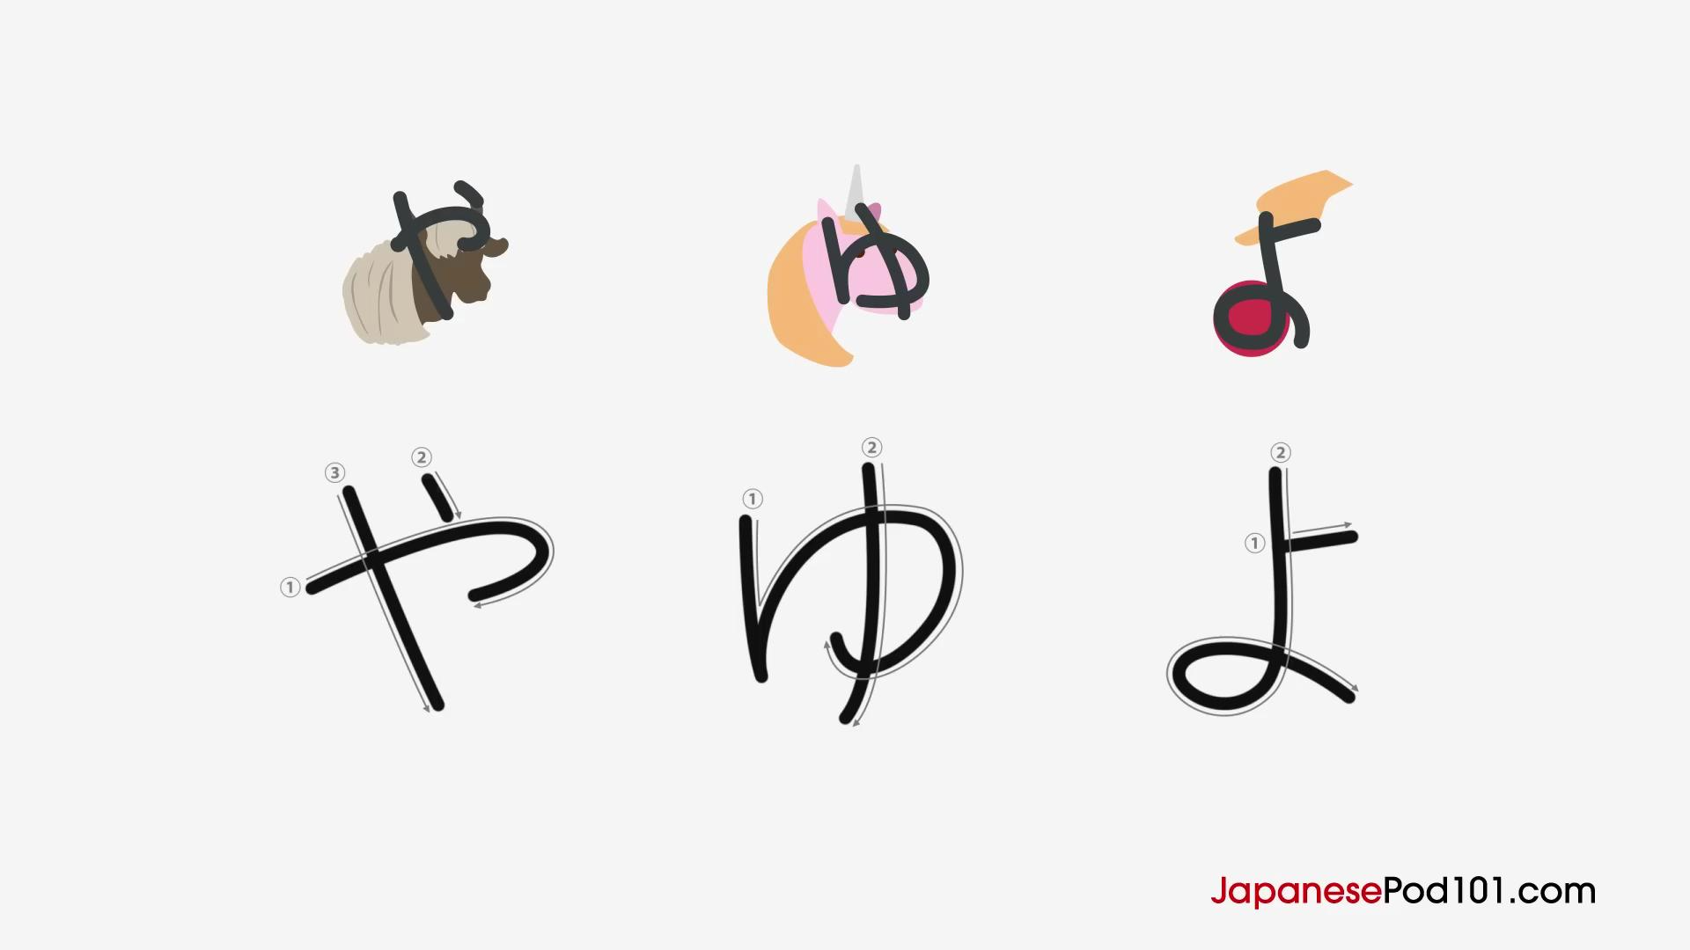

Y Column
や (ya)
Mnemonic: A yak with horns.
ゆ (yu)
Mnemonic: A unicorn.
よ (yo)
Mnemonic: A yo-yo.

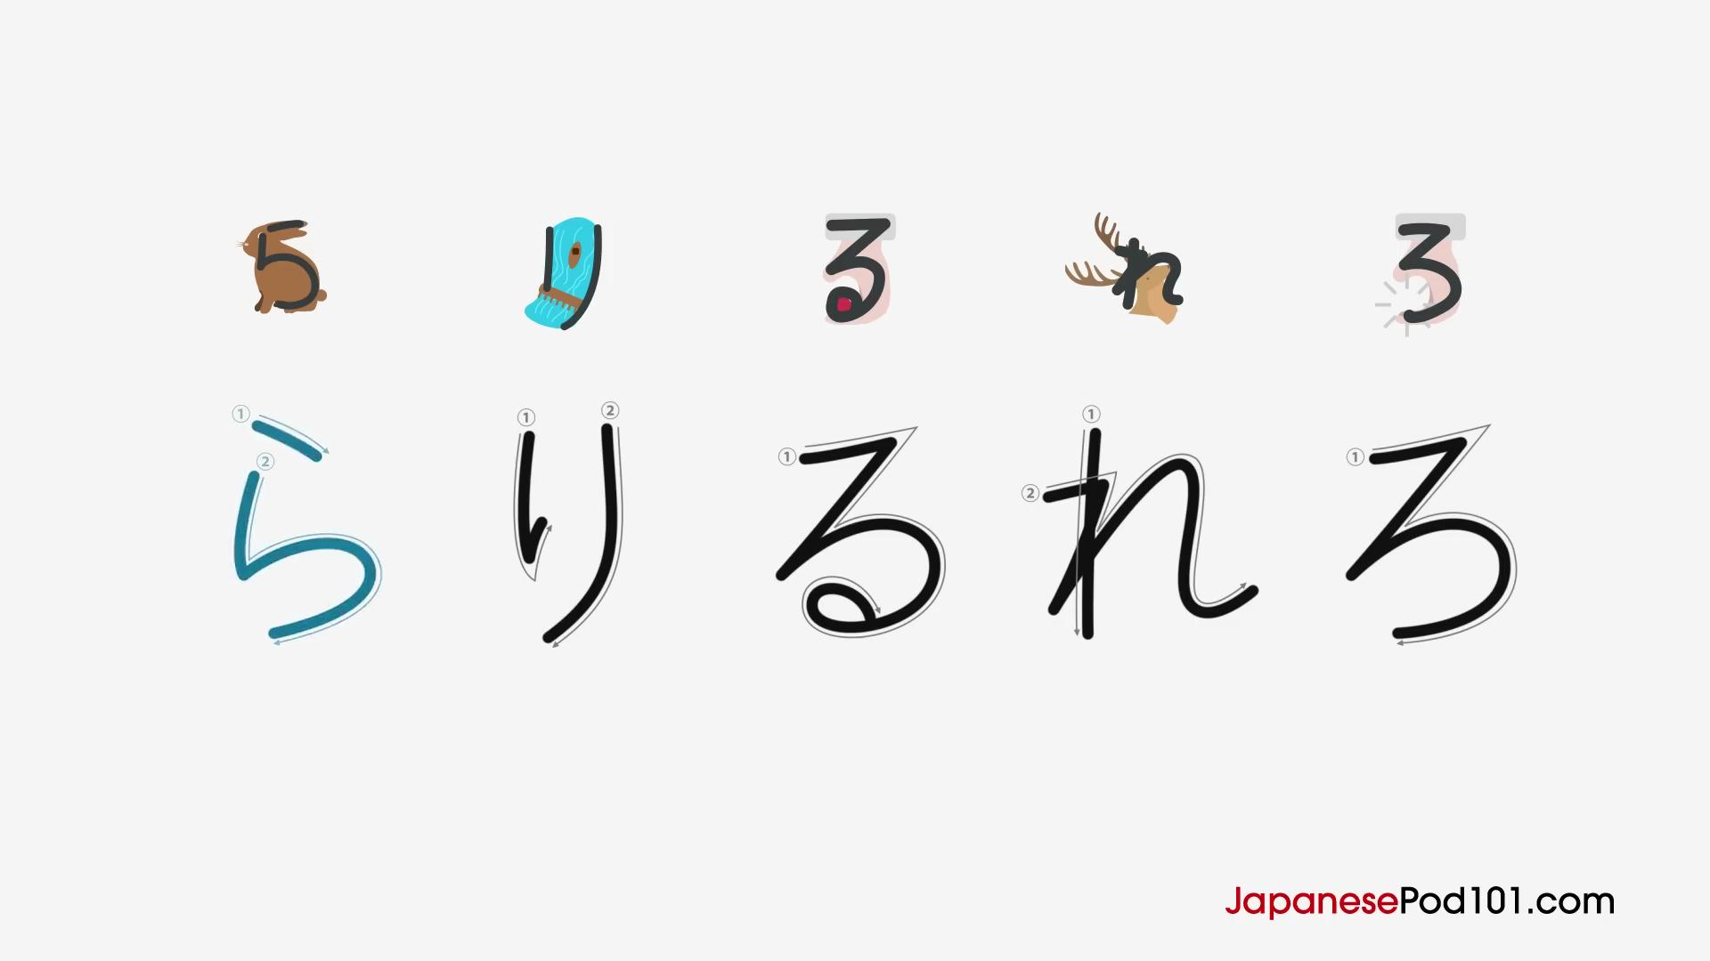

R Column
ら (ra)
Mnemonic: A rabbit sitting.
り (ri)
Mnemonic: Two lines like a river flow.
る (ru)
Mnemonic: A hand holding a ruby.
れ (re)
Mnemonic: A reindeer looking up.
ろ (ro)
Mnemonic: Something got robbed (missing ruby).

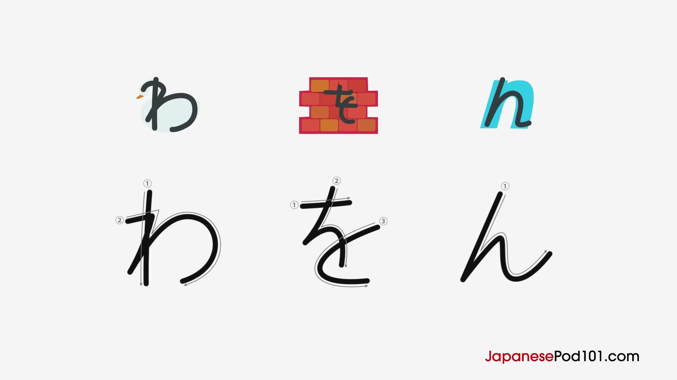
W Column
わ (wa)
Mnemonic: A white swan.
を (wo / o)
Mnemonic: A crack in the wall.

N (đặc biệt)
ん (n)
Mnemonic: Looks like a simple "n".

